**MM 226 Supervised Learning project consent form**

**PART II _ Submission**

**Name of project supervisor(s)**: Prof. Prasanna Kumar S. Mural

**Title of project:** AI-driven Smart Gloves for Motion Detection

**Project participant details: (Max 5 participants)**

| **Roll Number** | **Name of Student** | **Role of participant in project** |
| --- | --- | --- |
| 21D110016 | M. Hassan Shaikh | Project Lead & AI Researcher |
| 21D110012 | Om Kulpe | Prototype Engineer & Software Developer |
| 21D110007 | Keloth Uday Krishna | Documenter & Prototype Engineer |
| 210110054 | Jai priyadarshi | AI Researcher & Experimentation |
| 210110038 | Dev Kumar acharya | Experimentation & Software Developer |

**Objectives of the project: the deliverables of the project must be clearly outlined.**

Develop smart gloves equipped with piezoelectric and triboelectric sensors to detect hand motion & gestures for sign language recognition

1. Designing & 3D printing Polyvinylidene fluoride polymer based triboelectric highly shape adaptive sensor for sensitive joint motion monitoring & tactile sensing, demonstrating it’s application in real-time human-machine interaction

2. Utilizing an Arduino micro-controller to develop a custom sketch program file that interface with a piezoelectric/triboelectric 3D printed sensor, enabling precise real-time signal recording, advanced processing and data logging for motion detection

3. Pre-Processing the signal using advanced Signal Processing techniques, apply moving window mechanism to construct input matrix and implement LSTM/Transformer/RNNs/ other hybrid models to achieve a proposed accuracy.

**Role of each member:**

We have decided the roles on basis of what individual wants to learn and hence allotted multiple roles(so it follows as primary & secondary roles).

Responsibility of each roles are as follows:

**Project Lead**

* Communicating with the project supervisor and TA regarding the status of the project
* Arranging lab visits for experimentation and resolving queries
* Arranging materials required for the project and budget management

**Documenter**

* Documenting the contents discussed in meetings for future reference
* Creating reports and presentations involved in the project

**Prototype Engineer**

* Assembling all components to build prototypes of the gloves
* Overlooking integration of the software and hardware involved

**Experimentation**

* Mechanical testing and structural analysis of materials used
* Electrical testing of microcontroller (Arduino)
* Establishing connection between the software and the electrical components

**AI Researcher**

* Researching about efficient techniques for motion detection
* Building and testing different AI models

**Software Developer**

* Building a program to detect and analyse signals coming from the glove
* Applying AI models to classify hand gestures

**Timeline of the project (in the format given below)**

| Month | Week | Assigned task |
| --- | --- | --- |
| August | I | 1. Brainstorming ideas 2. Setting objectives 3. Finalising project details |
| II |
| III | 1. Processing polymer to generate filament 2. 3D printing components 3. Mechanical testing and structural analysis |
| IV |
| September | I | Integration of all physical components of the smart glove |
| II |
| III | **MIDSEM** |
| IV |
| October | I | 1. Software development and AI model building 2. Connecting software to hardware 3. Testing and modifying |
| II |
| III |
| IV |
| November | I | Ideating and planning the usage of this technology in other domains |
| II |
| III | **ENDSEM** |
| IV |

**Mid- semester progress**

**1] Key achievements thus far**

Mode Selection:

* Explored two sensing modes: contact-separation and linear-sliding.
* Choose linear-sliding mode for voltage generation based on triboelectric motion detection.

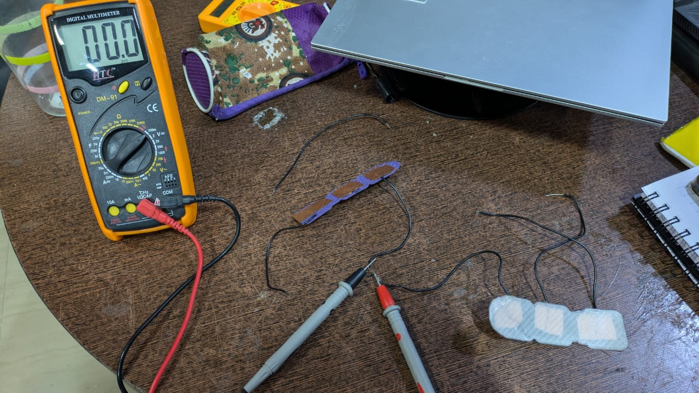

A setup to test triboelectric sensor with multilayer sliding configuration

Material Selection:

* Evaluated different materials for triboelectric sensors, settling on PVDF, PLA, nylon and ABS.

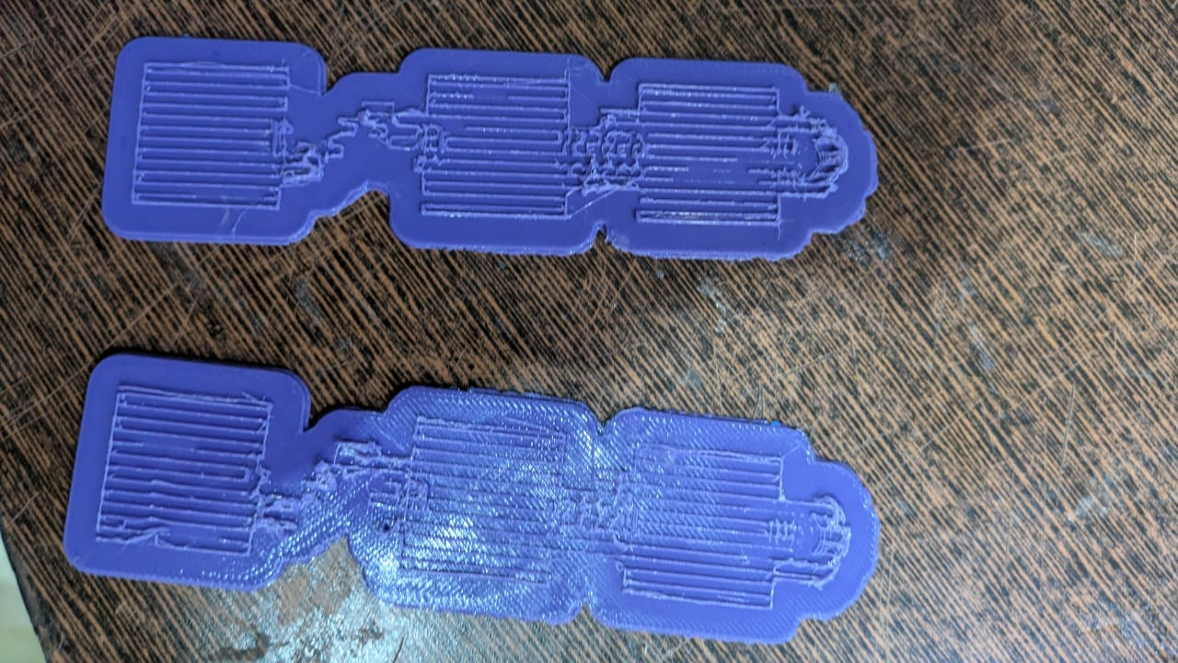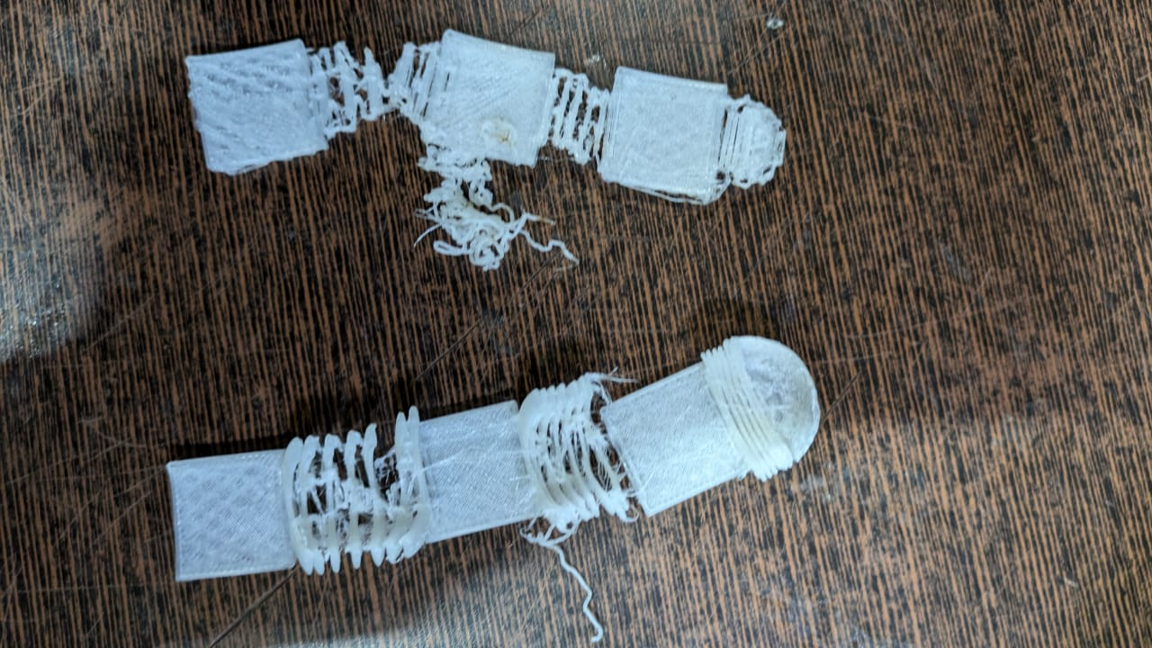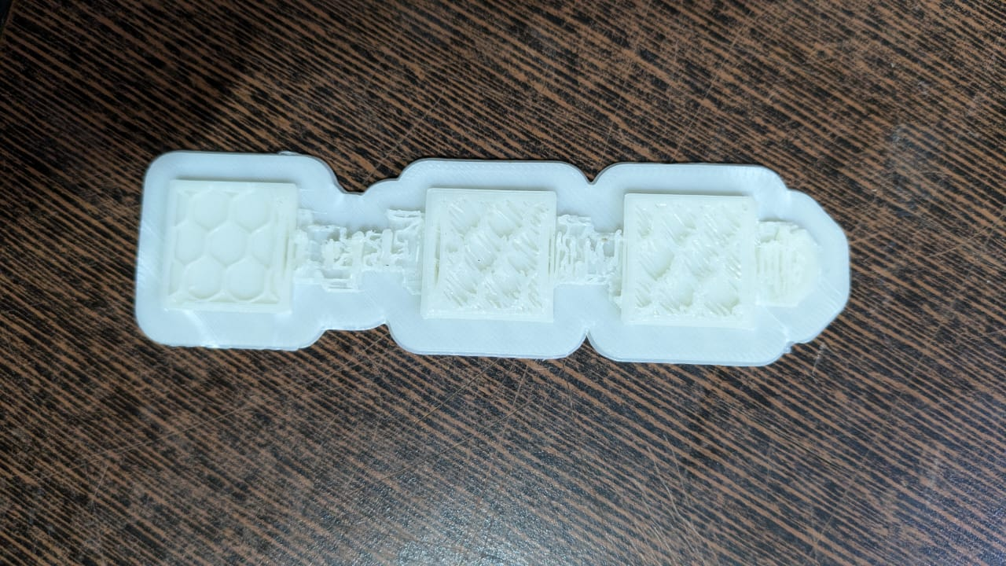

3D printed PLA strips 3D printed Nylon strips 3D printed ABS strips

Sensor Structure Design:

* Finalized the structural design of the triboelectric sensors through team discussions.
* Created 3D models of the sensor structures using Blender software for precise fabrication.
* Designed a multi-layer structure to accompany the triboelectric behavior according to linear sliding configuration.

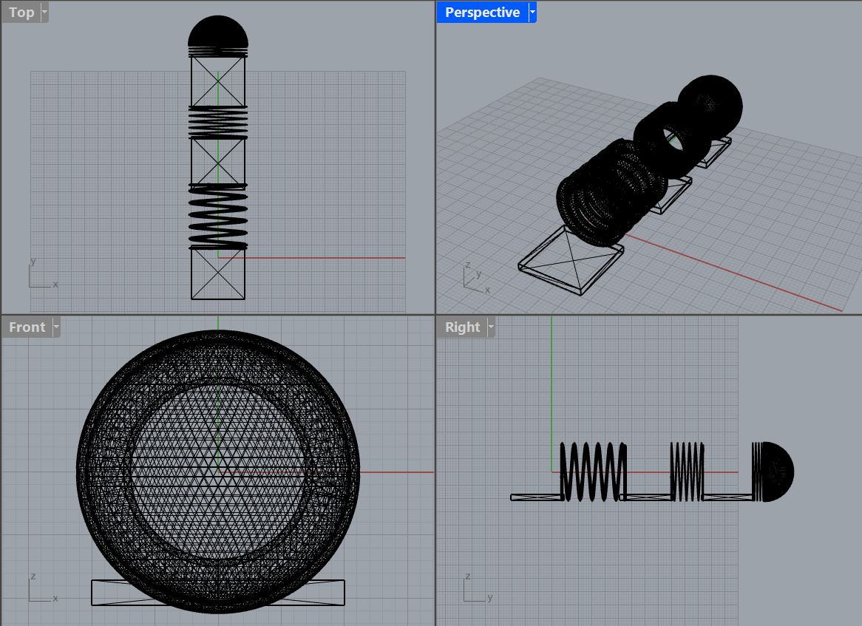

3D Printing of Sensors:

* Produced PVDF filaments in the polymer processing lab for sensor fabrication.
* Utilized Flashforge Guider IIs 3D printer to print multiple polymer strips(as discussed above) for testing the triboelectric effect.

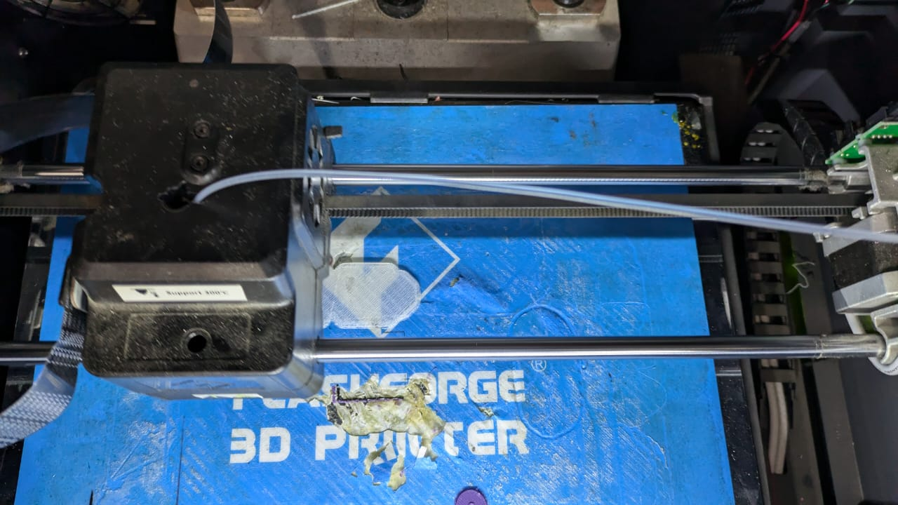

Component Procurement:

* Ordered essential electronics components, including Arduino microcontrollers, breadboards, and nylon gloves via Amazon.
* Purchased additional components (copper tape, resistors, lead wires, USB cable, multimeter) from local electronics stores.

Sensor Assembly:

* Attached copper electrodes to the sensors using copper tape for effective signal conduction.
* Connected sensors to the multimeter using lead wires for voltage measurement.

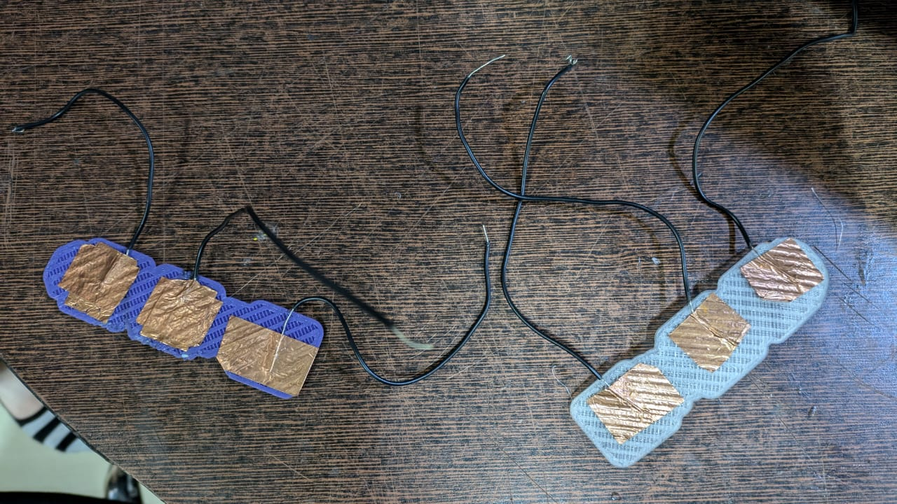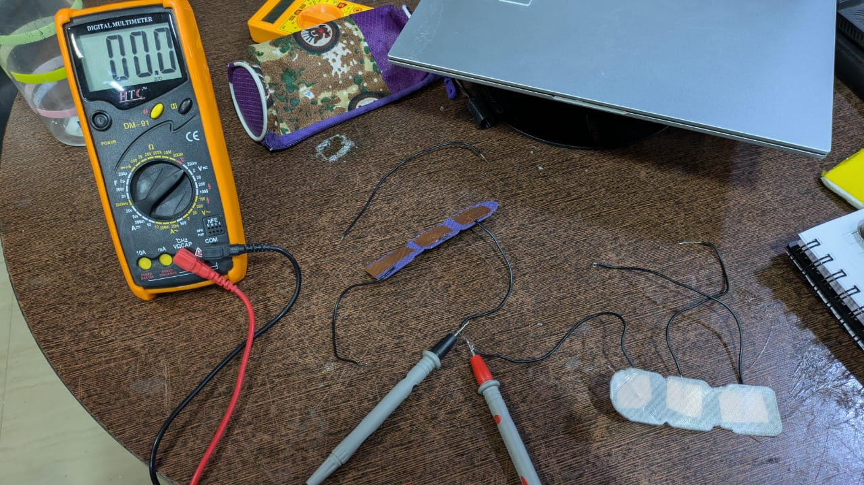

Testing and Measurement:

* Tested the sensors by rubbing positive triboelectric materials (nylon) over negative triboelectric materials (PLA, ABS).
* Achieved measurable voltage outputs in the range of 2.0x200-4.0x200 mV, indicating successful triboelectric charge generation.

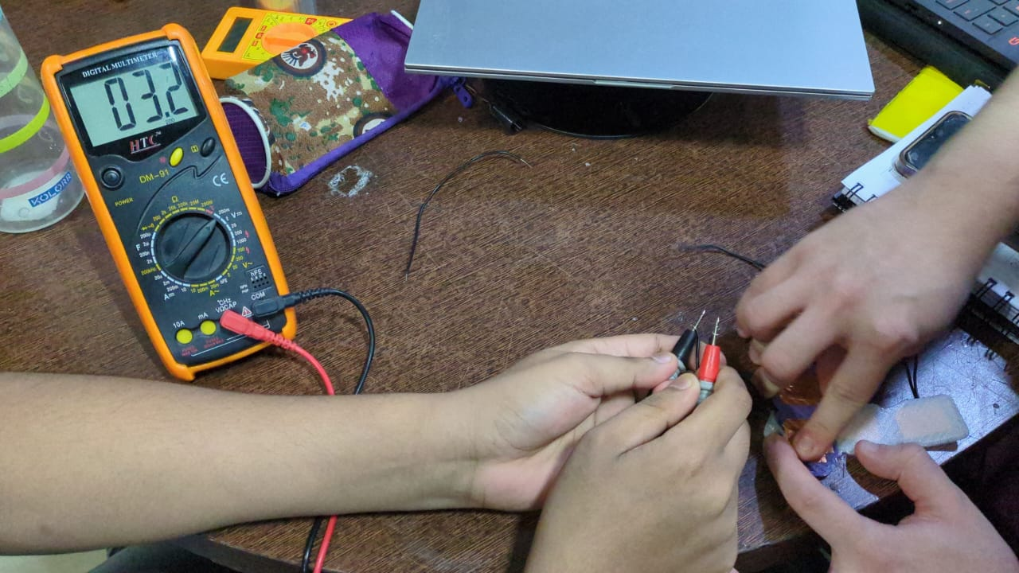

**2] Challenges faced and solved**

PVDF Filament Moisture capture

* During 3D printing, the PVDF filament exhibited a blackish color due to moisture exposure.
* To address this, we planned to remade the filament and implemented a storage solution using moisture-free containers with silica gel.

Nylon Sensor Printing Issues

* Initial attempts to 3D print nylon sensors were unsuccessful due to material compatibility issues with the printer.
* Through experimentation, we determined the optimal printing temperature to be 230°C, slightly above nylon's melting point (220°C), resolving structural inconsistencies that arose at lower (230°C) and higher (250°C) temperatures.

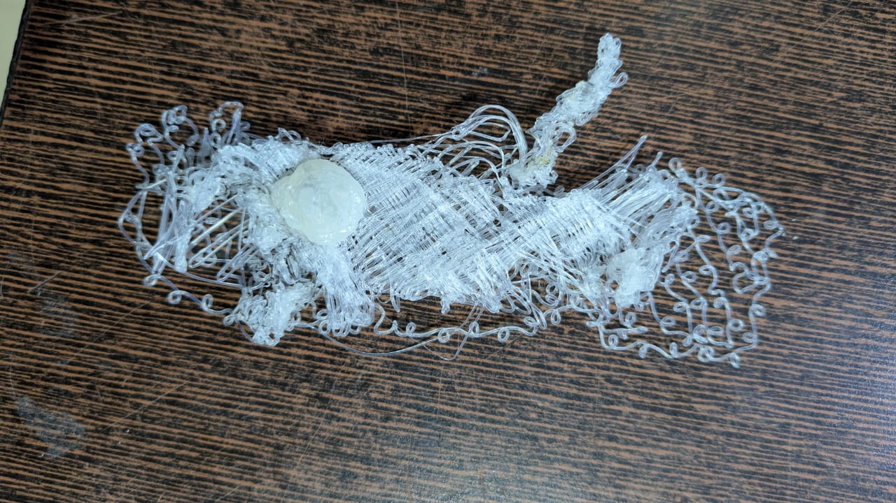

at 230°C at 250°C(over melt)

Sensor Structure Design

* We tested three designs for the sensor: (a) long rectangular strips, (b) rectangular strips joined with zig-zag springs, and (c) rectangular strips joined with solenoid-shaped springs.
* The first design lacked aesthetics, and the second was difficult to assemble due to the need for additional materials.
* We chose the third solenoid design for its simplicity and structural viability.

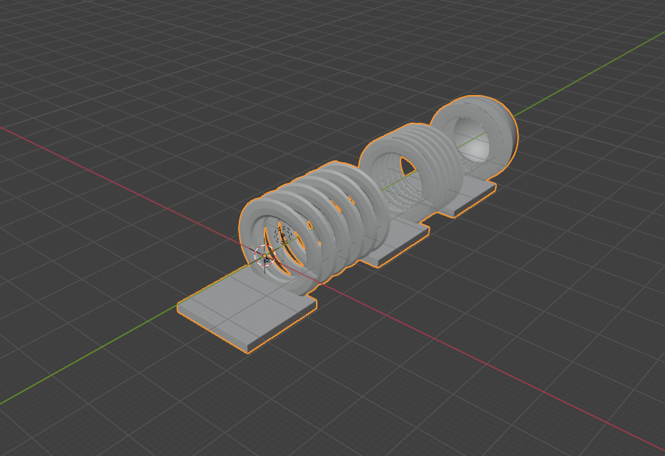

Sensor Attachment Method

* Initially, we used double-sided tape to attach sensors to the glove, but it added unnecessary insulation.
* We switched to wrapping Kapton tape around the sensor and glove fingers, providing a more suitable attachment method without compromising performance.
* We are yet to assemble this but have tested without it.

Triboelectric Sensing Model

* We compared two sensing modes: contact separation and linear sliding.
* Contact separation required complex mechanical assembly, so we opted for the linear sliding mode, which offered a simpler and more feasible implementation.

**3] If any changes in the project, then clearly mention the new objectives.**

There are no changes in the project. We have already achieved one of our objectives, that is,

* *Designing & 3D printing Polyvinylidene fluoride polymer based triboelectric highly shape adaptive sensor for sensitive joint motion monitoring & tactile sensing, demonstrating it’s application in real-time human-machine interaction*

The remaining objectives are

* *Utilizing an Arduino micro-controller to develop a custom sketch program file that interface with a piezoelectric/triboelectric 3D printed sensor, enabling precise real-time signal recording, advanced processing and data logging for motion detection*
* *Pre-Processing the signal using advanced Signal Processing techniques, apply moving window mechanism to construct input matrix and implement LSTM/Transformer/RNNs/ other hybrid models to achieve a proposed accuracy*

**Timeline – Part II Submission**

The parts highlighted in green have been completed. We are right on track as per our initial timeline.

| Month | Week | Assigned task |
| --- | --- | --- |
| August | I | Brainstorming ideas  Setting objectives  Finalising project details |
| II |
| III | Processing polymer to generate filament  3D printing components  Mechanical testing and structural analysis |
| IV |
| September | I | Integration of all physical components of the smart glove(sensor assemble) |
| II |
| III | **MIDSEM** |
| IV |
| October | I | Software development and AI model building  Connecting software to hardware  Testing and modifying |
| II |
| III |
| IV |
| November | I | Ideating and planning the usage of this technology in other domains |
| II |
| III | **ENDSEM** |
|  |